

**MIDDLE EAST TECHNICAL UNIVERSITY**

**Electrical and Electronics Engineering Department**

**EE-462 EE-464**

**Term Project**

**Report**

**Fall 2021**

**Ertuğrul Yolcu – 2305779**

**Goktug Tonay - 2305506**

**Introduction**

In this project, we are responsible for the creating converter, inverter, modulator and also control system of the SMPMSM. In the beginning of the project, some of the calculations related to the next steps of the project will be done in the pre-design stage. After that, three different driver model will be implemented with different control loops. After that, this control loops will be tested with the different conditions to be able to compare different operating points. At the last step of the project, component selection will be investigated and losses will be calculated.

**Part A: Pre-design Stage**

**1)**

In order to find the base speed of the machine, we need to use the operation point at the maximum torque and power. Then, the calculations will be:

Pnominal=120kW

Tnominal=350Nm

After that, we need to find the vehicle speed corresponding to base speed.

**2)**

Maximum electrical frequency can be found from the maximum speed which is 14000 rpm which is equal to 1466 rad/sec.

Then, we can modulate our signal with the ten times of the frequency of the signal. So our switching frequency of the inverter can be 10kHz.

**3)**

Our DC link ripple frequency is equal to 150Hz, with a current which cannot be ignored magnitude of ripple will be huge. To filter that component, an LC filter is selected. Values of the filter components calculated with analyzing frequency response and optimized with Simulink simulation.

ışık içeren bir resim

Açıklama otomatik olarak oluşturuldu

figure 1 Designed Filter

Designed filter and values of the filter can be seen above. To test the filter output, output is loaded with 1ohm resistor. Ripple voltage can be seen below.

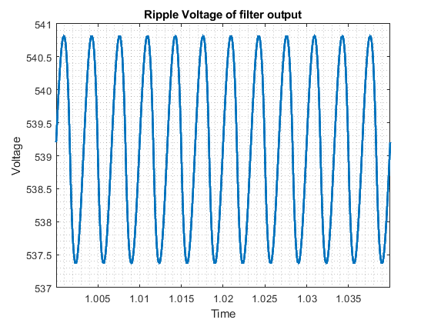

Figure 2: Voltage waveform

**Part B: Sinusoidal PWM**

**Drive Model 1)**

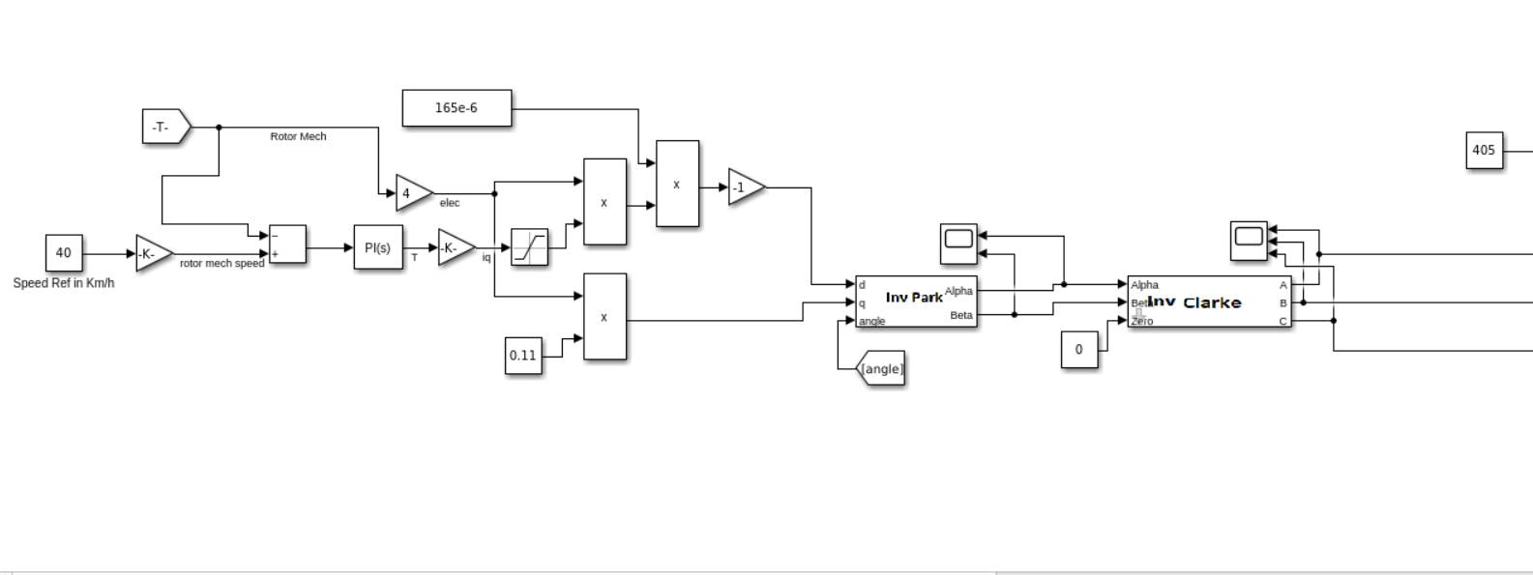

figure 3 Schematic of the model 1 Part 1

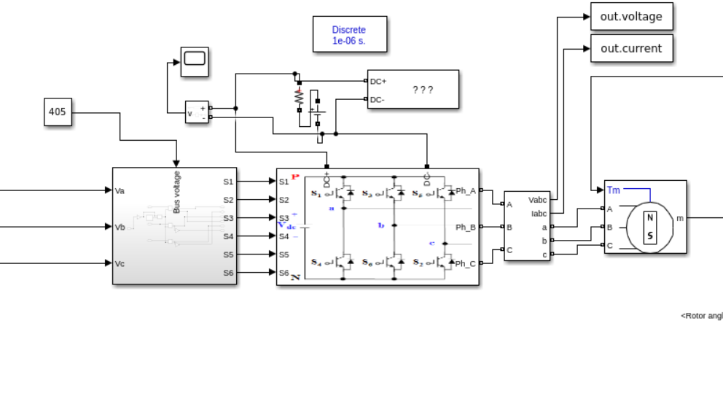

figure 4 Schematic of the model 1 Part 2

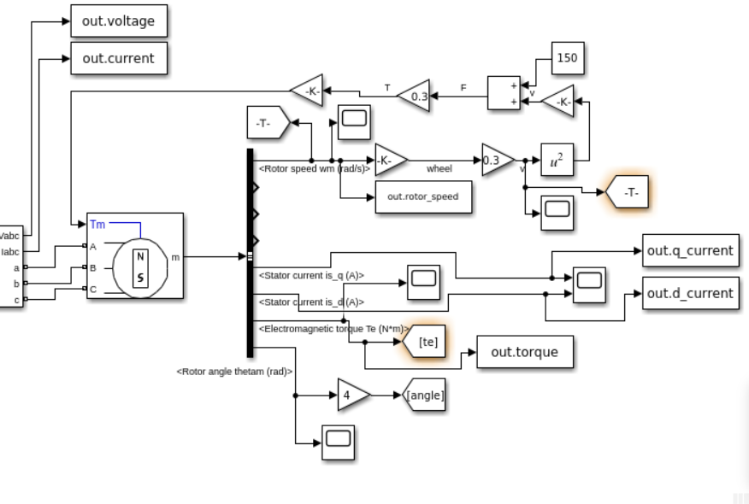

figure 5 Schematic of the model 1 Part 3

**Drive Model 2)**

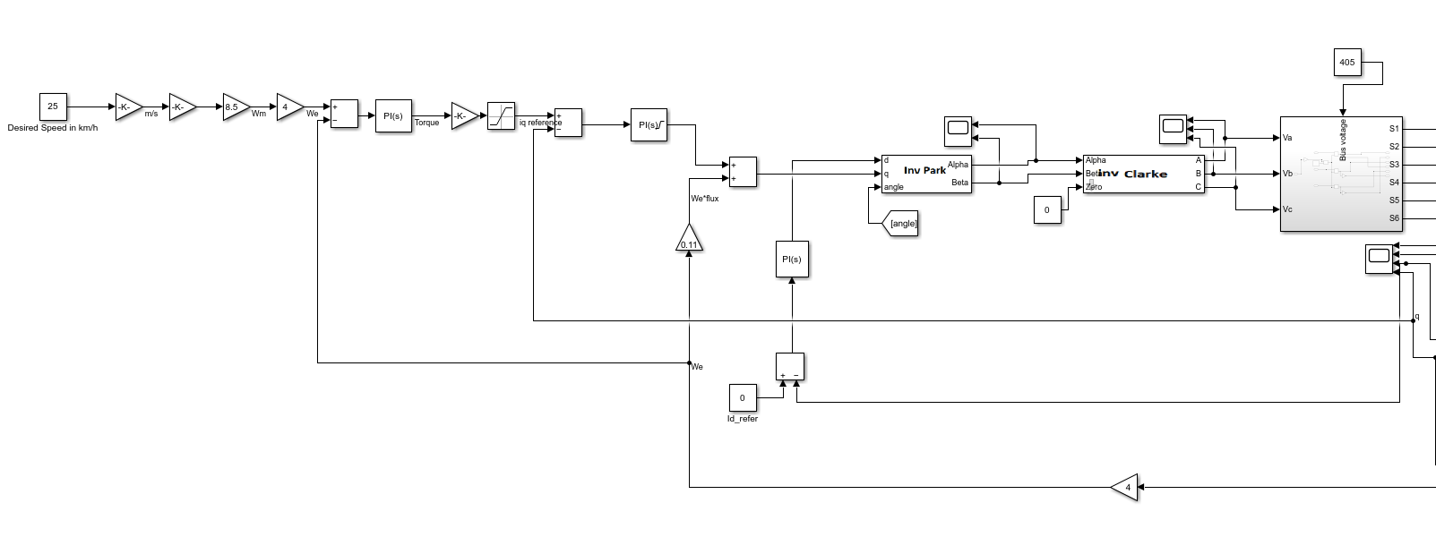

figure 6 Schematic of the model 2 Part 1

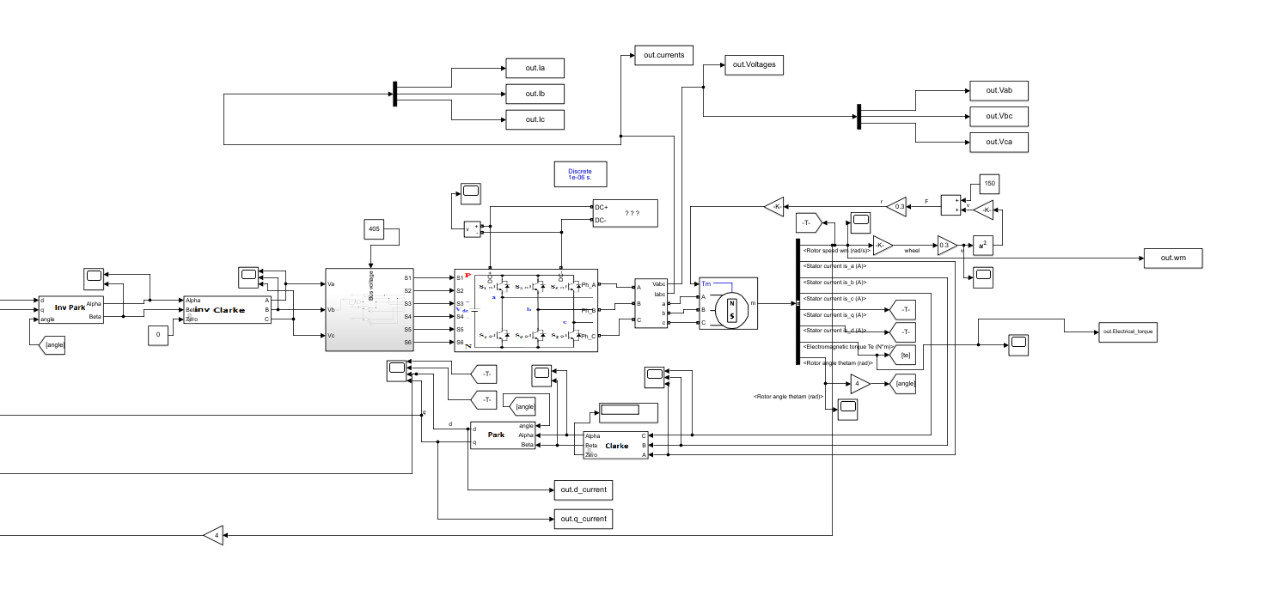

figure 7 Schematic of the model 2 Part 2

**Drive Model 3)**

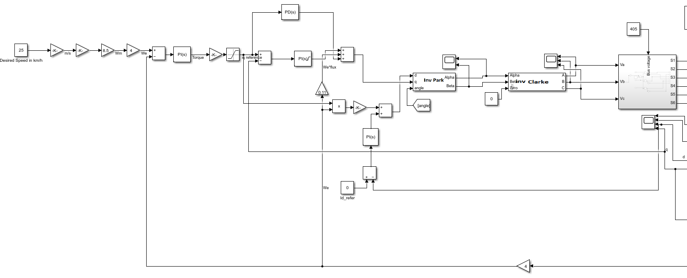

figure 8 Schematic of the model 3 Part 1

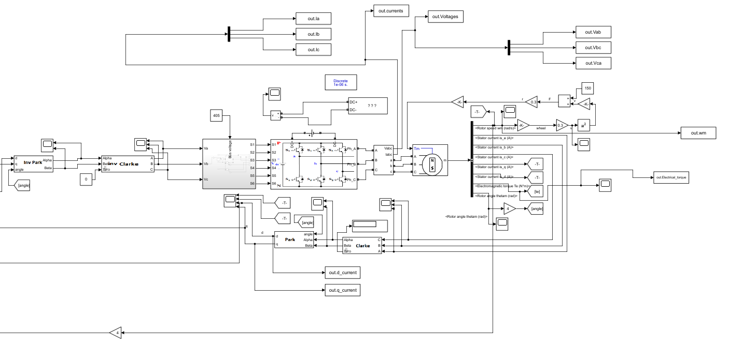

figure 9 Schematic of the model 3 Part 2

**Part B 1)**

**1.a)**

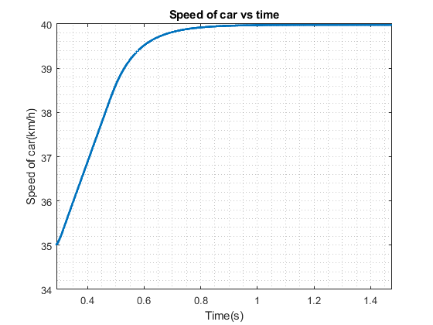

figure 10 Speed of car vs time Drive model 1

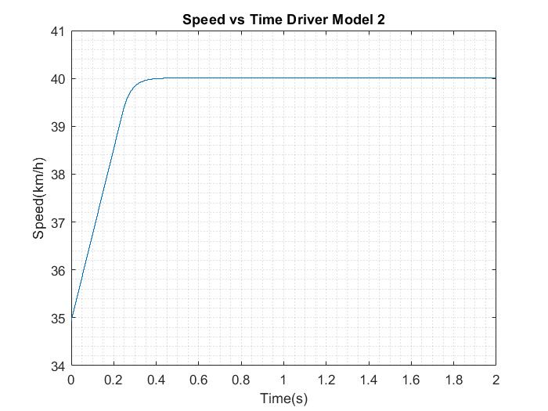

figure 11 Speed of car vs time Drive model 2

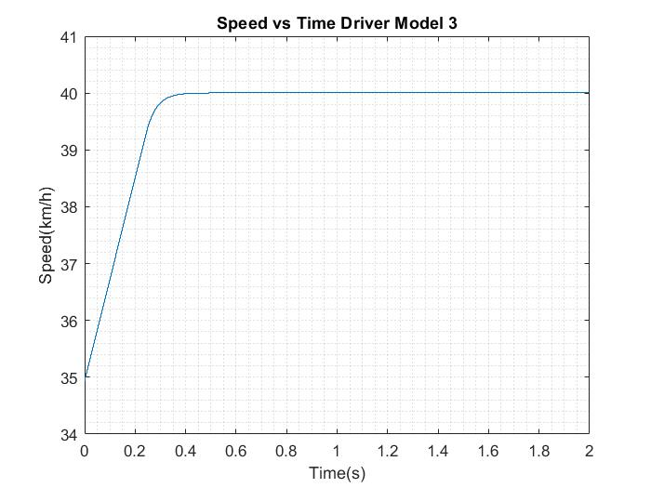

figure 12 Speed of car vs time Drive model 3

**1.b)**

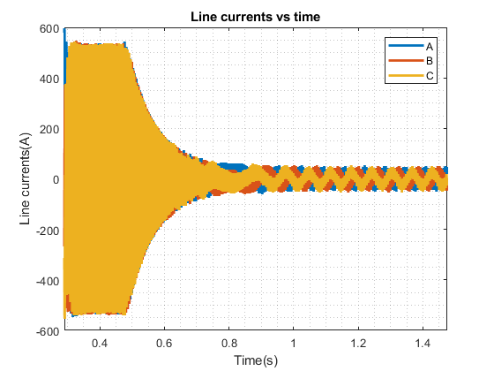

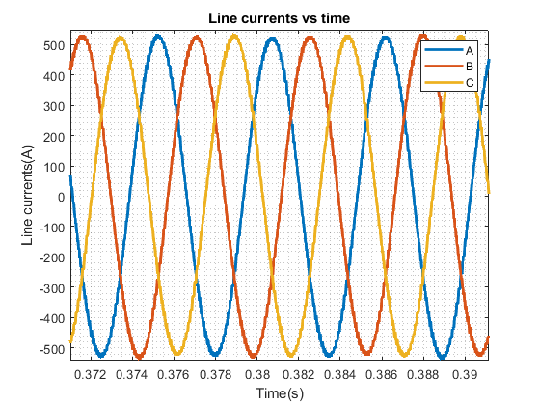

figure 13 Three phase line currents of model 1

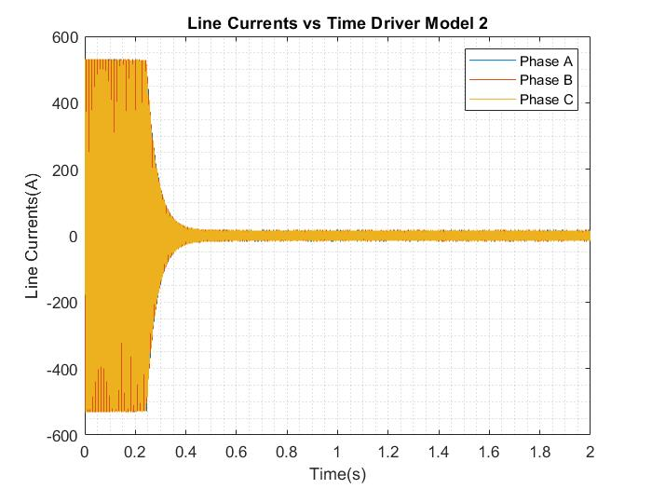

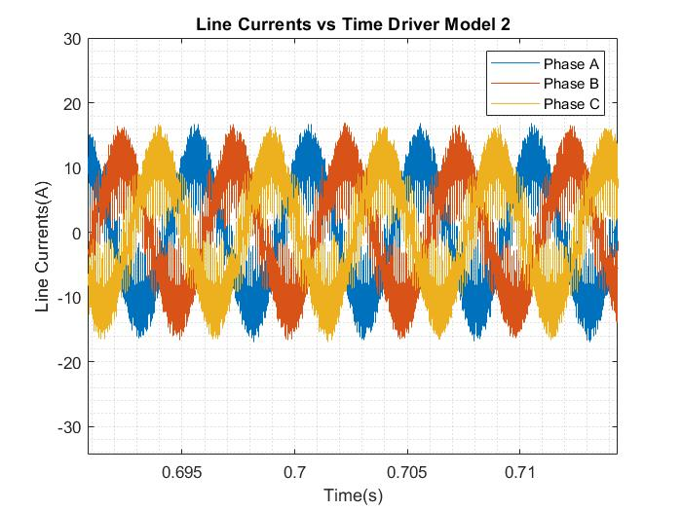

figure 14 Three phase line currents of model 2

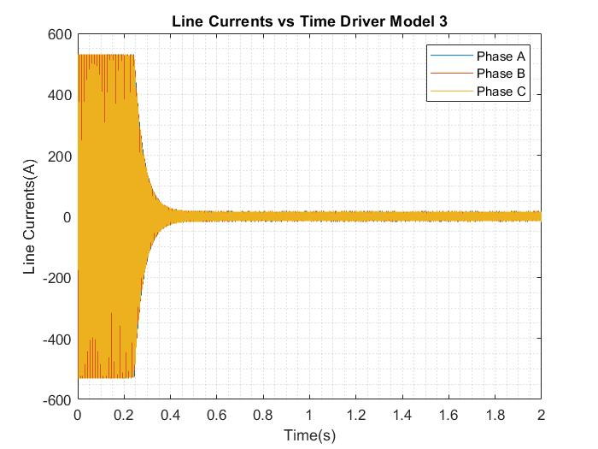

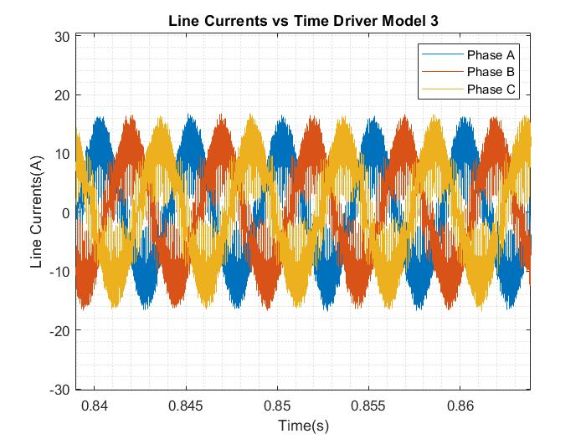

figure 15 Three phase line currents of model 3

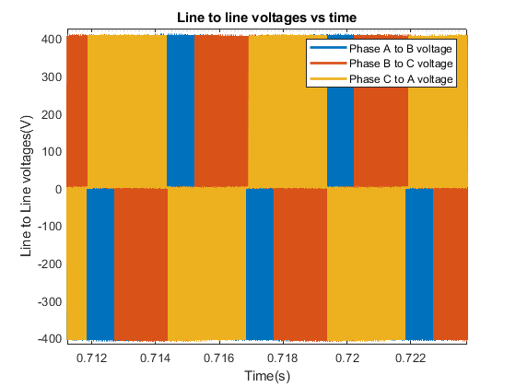

figure 16 Three phase line Voltages of model 1

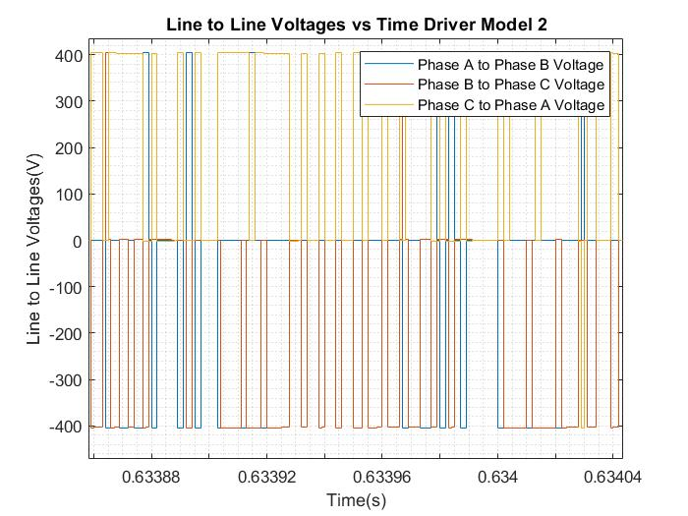

figure 17 Three phase line voltages of model 2

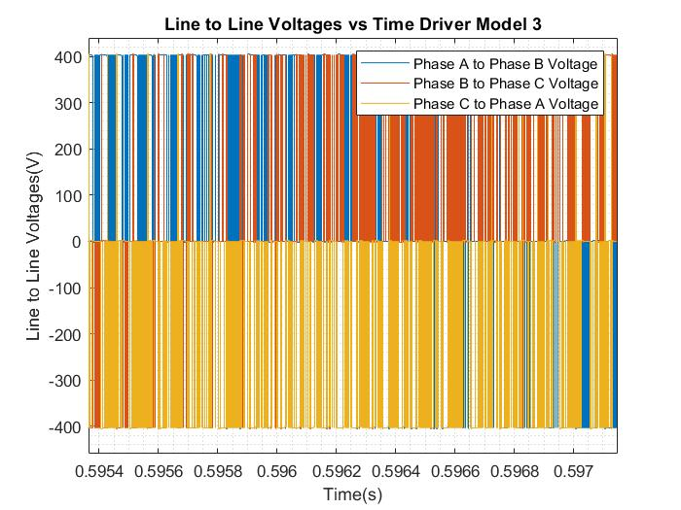

figure 18 Three phase line voltages of model 3

**1.c)**

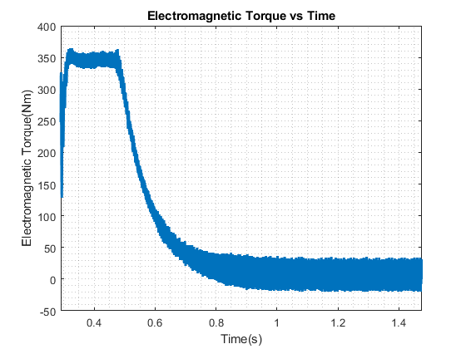

figure 19 Electromagnetic Torque vs time for model 1

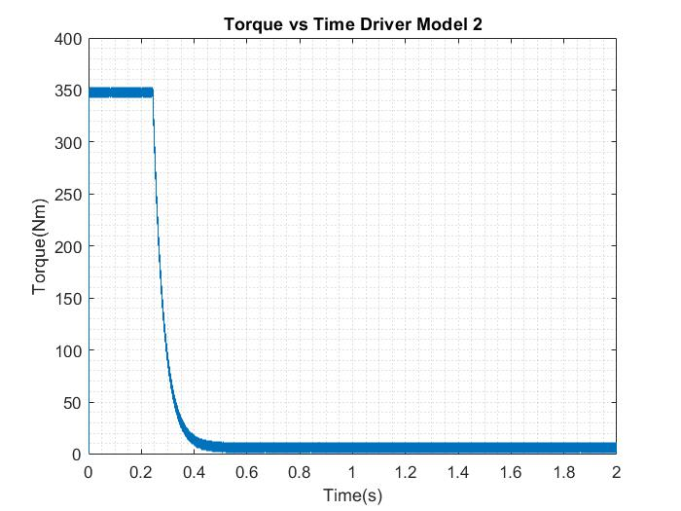

figure 20 Electromagnetic Torque vs time for model 2

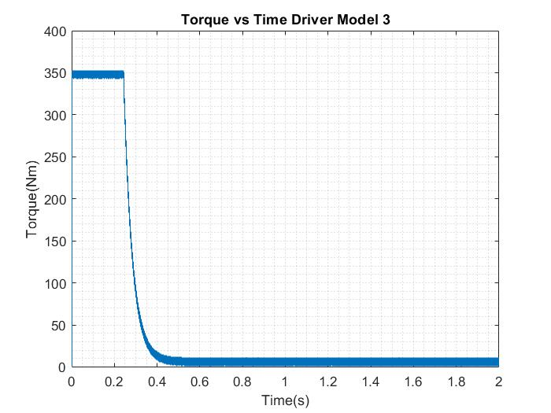

figure 21 Electromagnetic Torque vs time for model 3

**1.d)**

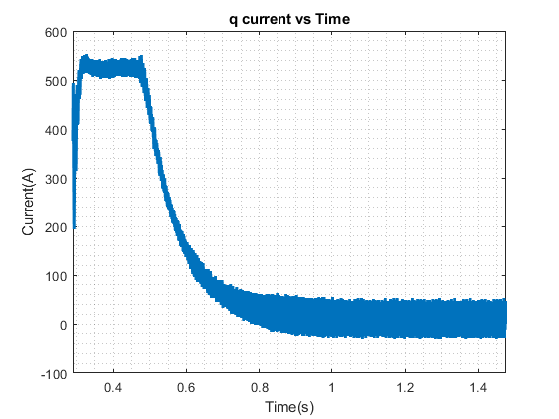

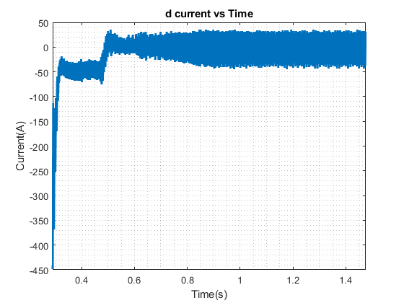

figure 22 dq currents vs time of model 1

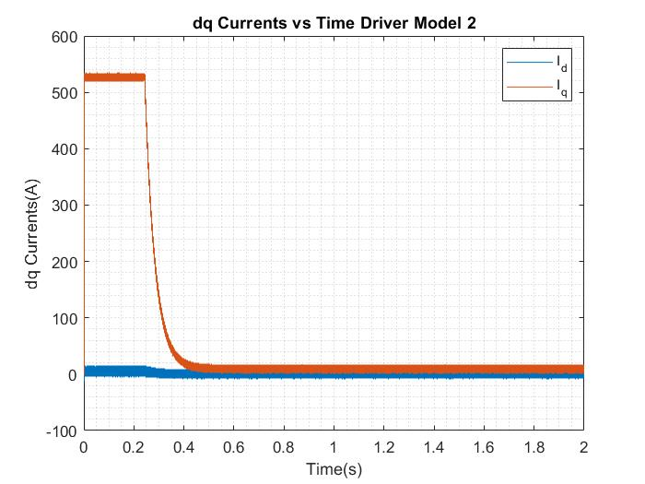

figure 23 dq currents vs time of model 2

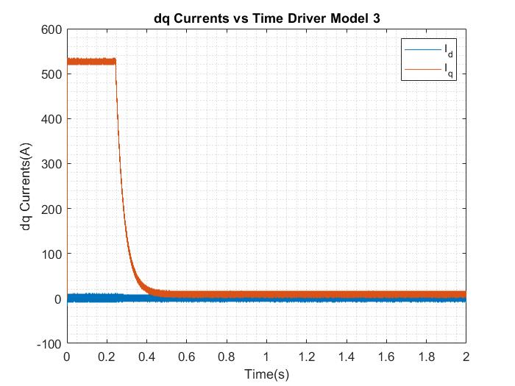

figure 24 dq currents vs time of model 3

**1.e)**

For the drive model 1, transition time is about 0.7 seconds. For the drive model 2, transition time is about 0.5 seconds and for the drive model 3 again transition time is about 0.5 seconds. It is expected to have better transition time for the drive model 2 and 3.

**Part B 2)**

Due to lack of inner current loop, drive model 1 results higher transient time and higher oscillating dq currents. Moreover, due to lack of inner current loop, the mean d axis current in the transient time is different than zero, this means that even though we don’t need to weaken the field, we mistakenly do field weakening, this results higher transition time. When we look for the drive model 2 and 3, both show great response, however a little but noticeable difference can be seen. Due to lack of feed forward path, drive model 2 has worse regulation than drive model 3 in terms of d axis current.

For the comparison of the electromagnetic torque, it shows the same behavior with the dq current graph. For the drive model 1, oscillates much in transients, however for the drive model 2 and 3 it again has great transient response due to better regulation in current.

If this models are needed to be developed, we just need to tune the PI controller. On the other hand, the tuning of the controllers is not easy in limited time. Because of that, we tried to find our best controllers.

**Part B 3)**

**3.a)**

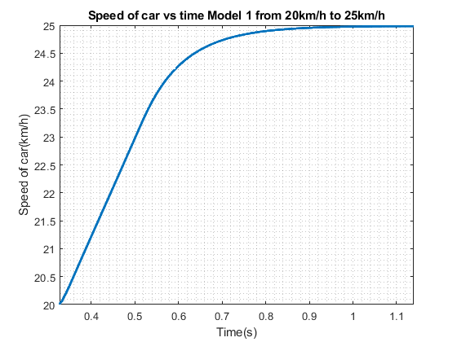

figure 25 Speed vs Time for model 1 from 20km/h to 25km/h

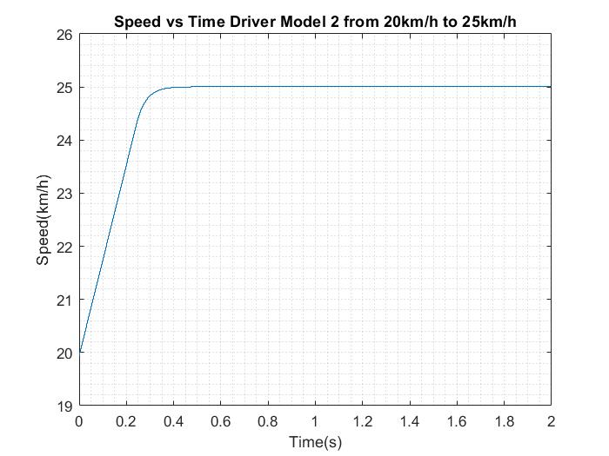

figure 26 Speed vs Time for model 2 from 20km/h to 25km/h

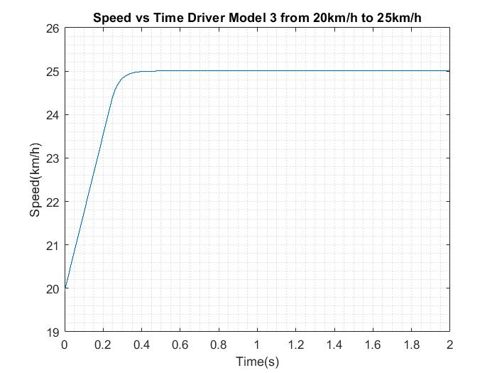

figure 27 Speed vs Time for model 3 from 20km/h to 25km/h

**3.b)**

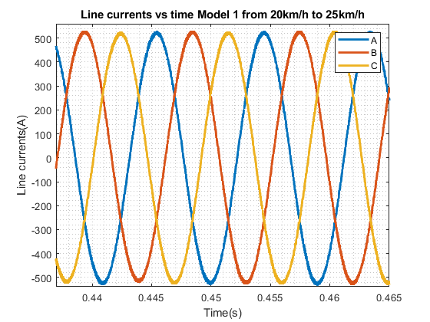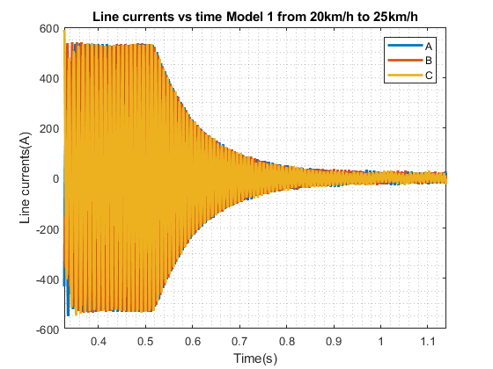   
figure 28 Line currents vs time for model 1 from 20km/h to 25km/h

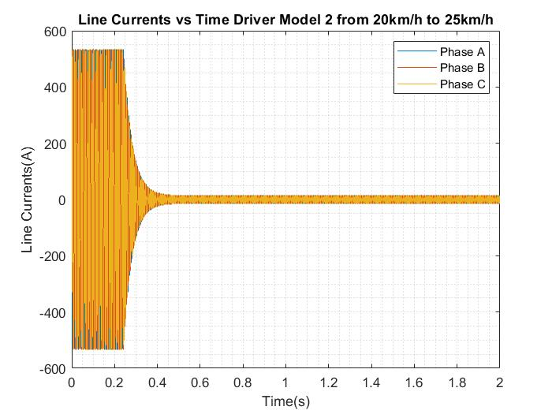

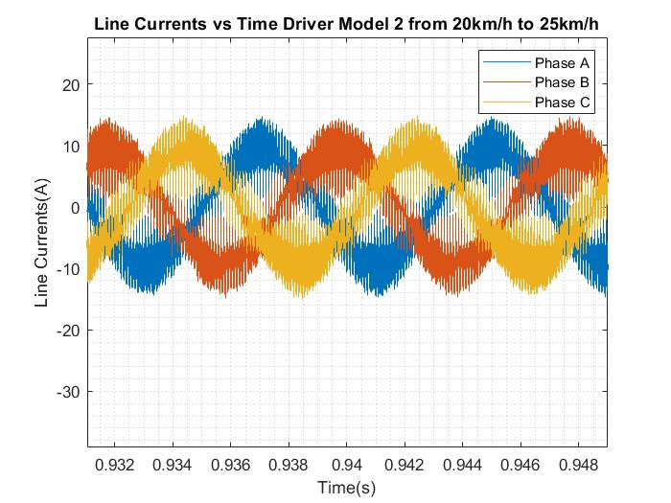

figure 27 Line currents vs time for model 2 from 20km/h to 25km/h

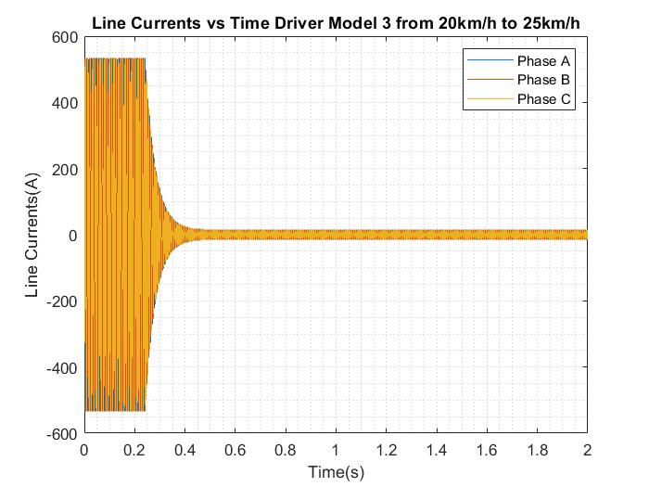

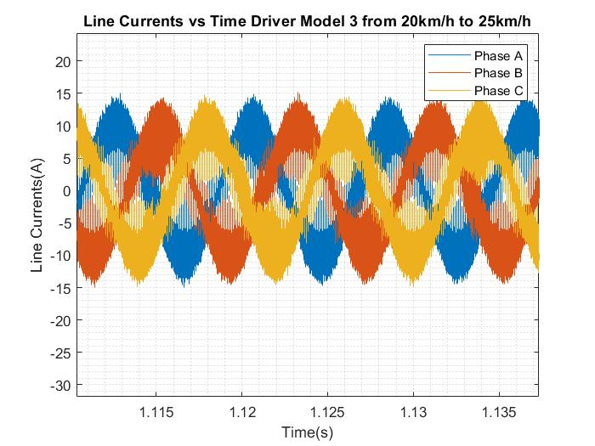

figure 28 Line currents vs time for model 3 from 20km/h to 25km/h

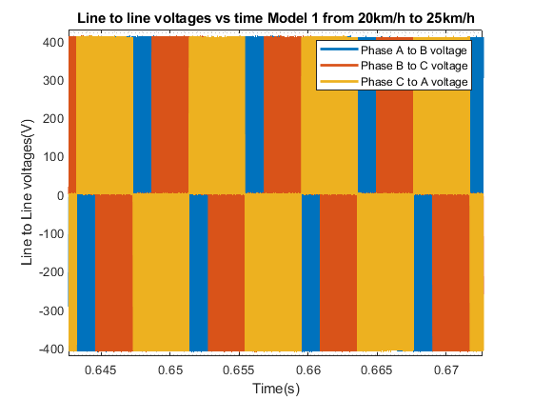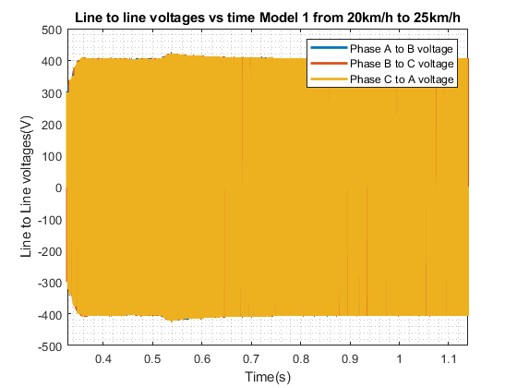

figure 29 Line voltages vs time for model 1 from 20km/h to 25km/h

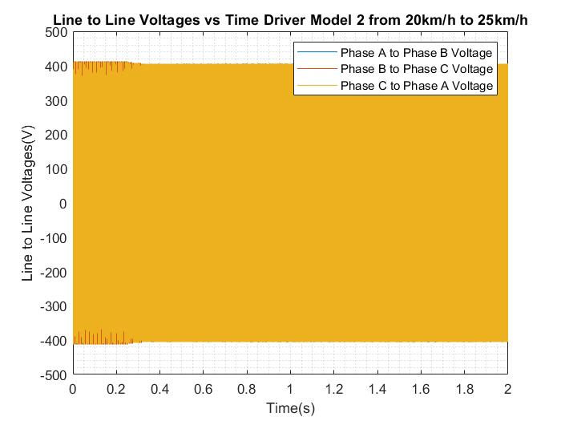

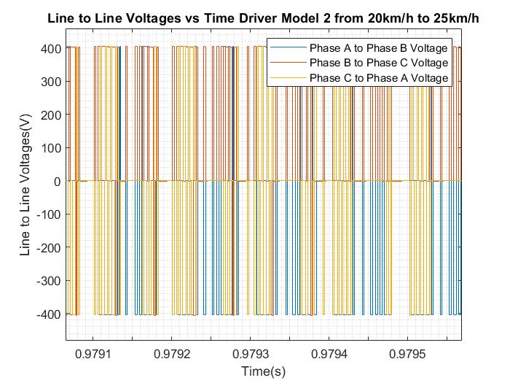

figure 30 Line voltages vs time for model 2 from 20km/h to 25km/h

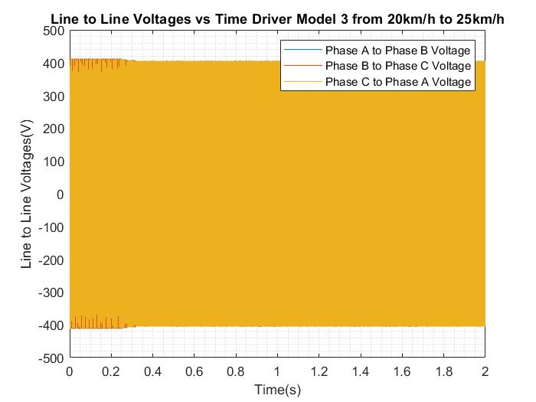

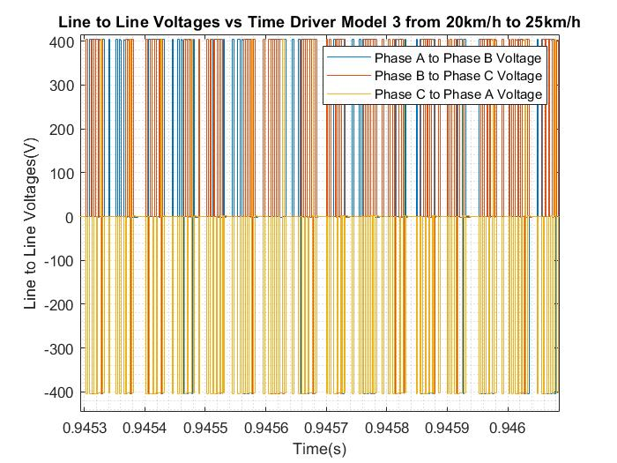

figure 31 Line voltages vs time for model 3 from 20km/h to 25km/h

**3.c)**

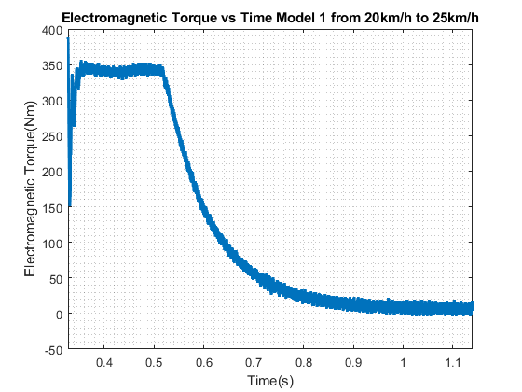figure 32 Torque vs time for model 1 from 20km/h to 25 km/h

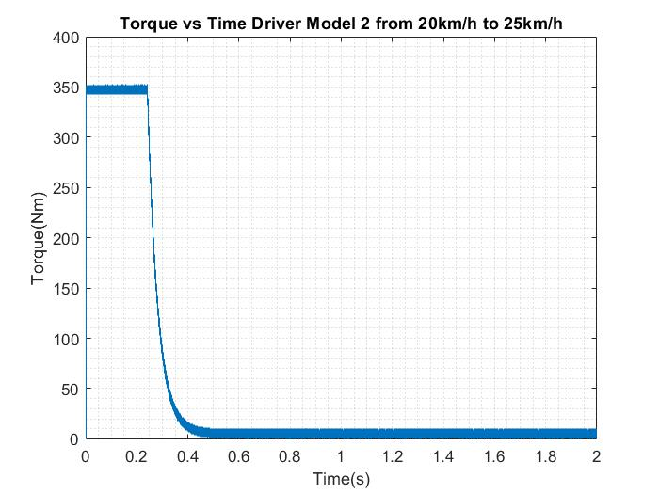

figure 33 Torque vs time for model 2 from 20km/h to 25 km/h

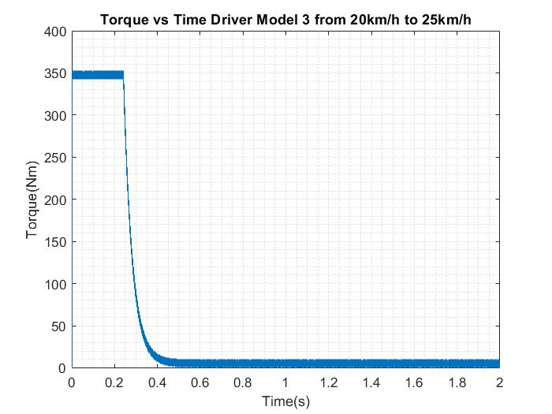

figure 34 Torque vs time for model 3 from 20km/h to 25 km/h

**3.d)**

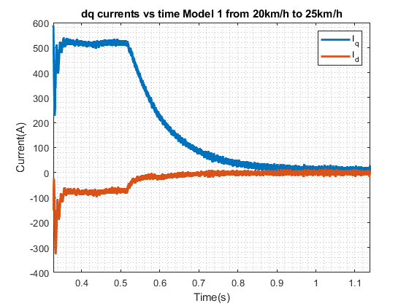  
figure 29 dq currents vs time for model 1 from 20 km/h to 25 km/h

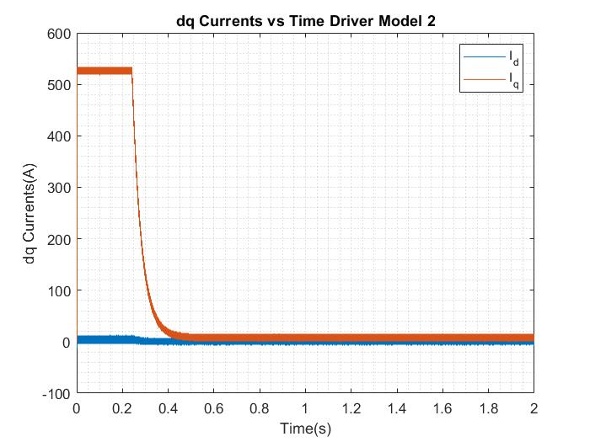

figure 30 dq currents vs time for model 2 from 20 km/h to 25 km/h

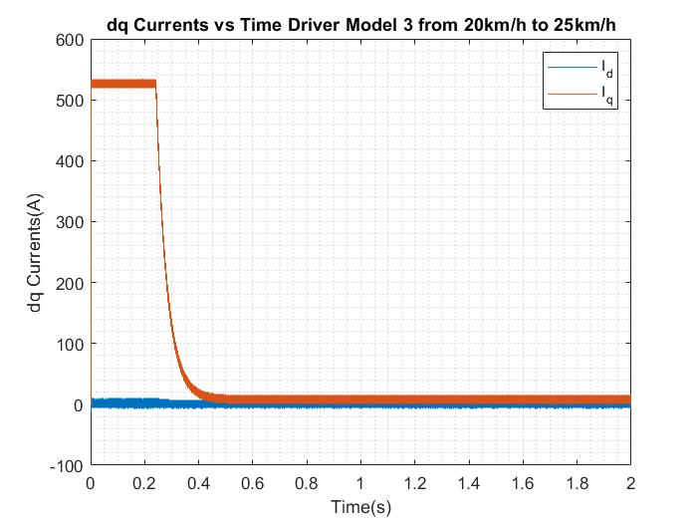

figure 31 dq currents vs time for model 3 from 20 km/h to 25 km/h

**3.e)**

Transition time for the drive model 1, for this case is approximately 0.75 seconds, for the drive model 2 and 3 it is again about 0.5 seconds, again model 3 has slightly better response. Due to lack of current loop, model 1 shows best response in tuned speed range. However, due to regulated current loops, drive model 2 and model 3 shows similar response.

**Part B 4)**

As can be seen from the plots above and answer given to 1.e and 3.e shows that, drive model 1 shows best response for its tuned range and steady state behavior, however drive model 2 and 3 has inner current loops, which results better response for a better range. Moreover, due to feedforward paths, model 3 shows better response than model 2. The reason behind this, the Pi controller are tuned in the condition of the 35 km/h to 40km/h. So, the transients are slightly good in part B.1 in every model.

**Part B 5)**

In this part of the project, the vehicle is driving at 40km/hat half of the rated torque. So this means that the d current of the control system can be found.

A

In addition to that, it is known that, the field weakening will be applied. So, limitation for the system is voltage. We can apply 202.5 V because of our modulation technique which is sinusoidal pwm. Then, Vdq voltage is known which is equal to 202.5 V. So, Id current can be found with this values as:

Then, Id is calculated as;

After all, we have implemented the new Simulink design for this case. The difference between the other parts, motor initial speed is equaled to 40km/h, Id current reference is set to 77 A, and the torque of the motor is equaled to 175 Nm. The results can be seen below:

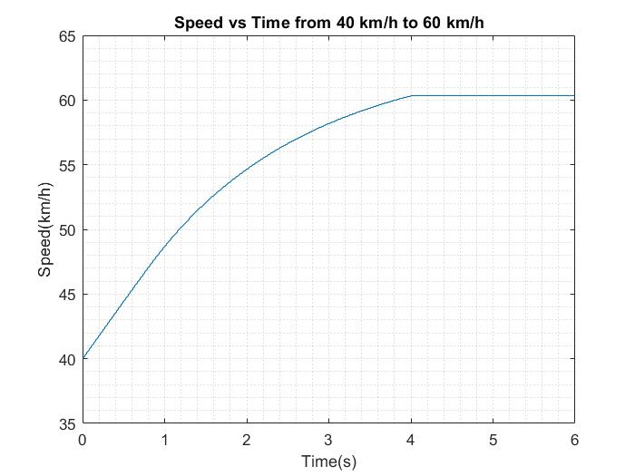

figure 34 Speed vs time from 40 km/h to 60 km/h

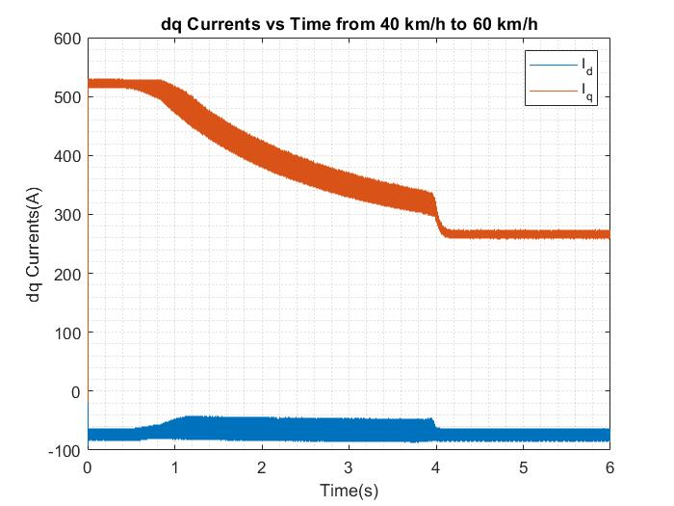

figure 32 dq currents vs time from 40 km/h to 60 km/h

**Part C: Component Selection**

**Part C 1)**

In this part of the project, we need to find a commercial switching device for the inverter. In order to find the correct choice, we need to specify the voltage and current ratings. As the signal is modulated with the sinusoidal pwm, the peak of the phase voltage will be equal to VDC/2 which is equal to 202.5 V. In addition to that, according to the given parameters, the current limitation is equal to 530 A. The ratings are quite high for the mosfet, because of that, the IGBT is chosen for the type.DD600R06ME3 model IGBT is selected which is created by Infenion. The voltage rating for this IGBT is equal to 600V and the current rating is equal to 600A which are both suitable for this case.

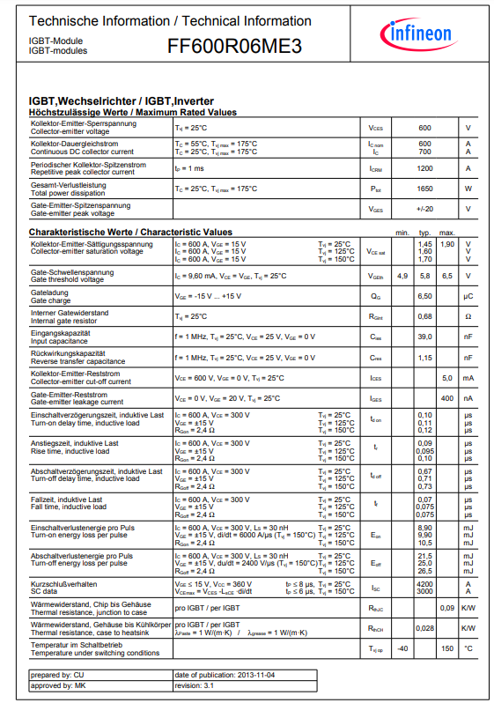

figure 36 Datasheet of the selected IGBT

**Part C 2)**

The losses of the inverter composed of three main branch. They are conduction losses, switching losses and stray losses. According to the selection of the switching device, the switching losses and conduction losses can be found with the parameters of the IGBT.

The voltage and current values at this operation needed to find:

As we can conclude, three of the switching devices are working together, so we can multiply assume the duty cycle as 0.5 and 6 of the switch result in 3 times of the Vce times current.

When the switching losses are calculating, one of the switched is selected as a reference and the worst case is calculated. Then this loss multiplied by 6.

In this part of the project selected switching element is an IGBT in a half bridge configuration, switches in the configuration single, half bridge, full bridge and 3 half bridge is easily available in the market. For our case it is beneficial to use single, half bridge or 3 half bridge configurations. However due to losses in the switching elements, each configuration has a different cooling system. For our case each module has approximately 1.2kW of loss, moreover due to mechanical structure of our modules we can directly connect our modules to the cold plate. This will allow us to have a good thermal management. In the case of 3 half bridge configuration, we will have all losses in the same module, hence it will require better thermal conductivity.

**Part C 3)**

For a driver for this switching device, MC33GD3100EKR2 is chosen. The advantages of this driver are isolated interface, active miller clamp, high sink and source current which is 8A. This result is better than the test results of the IGBT.

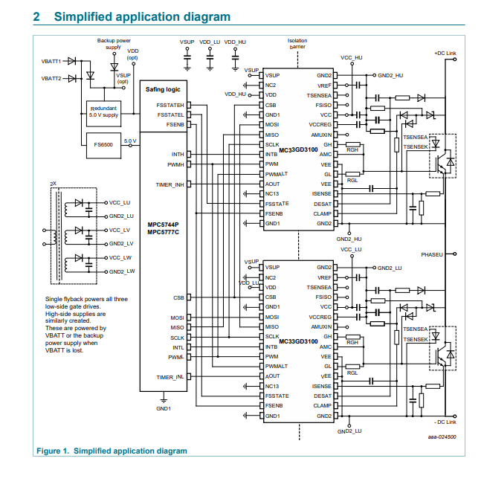

figure 33 Diagram of the driver circuit

**Conclusion**

In this project, we simply model electric vehicle traction system, we controlled the inverter with different control algorithms and compare effects of it. At the beginning of the project, we have created a rectifier to supply a DC voltage to the inverter. After that, the inverter is designed for the driving motor. Then, the control system of the surface mounted permanent magnet synchronous machine is established with using just speed feedback. After this step, the control loop of the machine is developed with the Id and Iq currents. At this step 3 different PI controller is used. After that step, feedforward loops are added to the schematic and the development of the results are observed. In the second part of the project, this models are tested with different conditions and the comparison was investigated. At the end of the project, the necessary switching devices are chosen and the losses of this devices are calculated. Thanks to this project, we have experienced the control of the SMPMSM designing inverter and converter.